**CHAPTER 1**

**INTRODUCTION**

**PROJECT CONTEXT**

Technology, a ground-breaking innovation that transformed lives in many aspects, have provided solutions to problems in our day-to-day life. The Technology Acceptance Model (TAM) states that the growing user acceptance of the technology is driven by the ease of use and usefulness it provides (Davis, 1989). The acceptance of users pushes industries to embrace and integrated new technologies into information systems which further revolutionizes these systems.

Uber, being first of its kind, became a global revolution in the industry of transportation services. Its creation was fueled by the frustrations of two computer engineers who had difficult time looking for a taxi in the streets of Paris – a prominent challenge in the industry at the time, the accessibility of transportation. The birth of Uber set the path for more ride-hailing applications to emerge with the aim of solving more challenges faced by the industry. And these applications gained the attention of users, particularly commuters, as they provide a flexible, convenience, and accessible platform to access transportation (Mitropoulous et al., 2021).

Cagayan State University – Gonzaga and its expansive grounds have posed a challenged to the student. With the tricycle terminal located outside of the campus, circumstances like inclement weather, the summer heat as well as heavy bags that students carry causes inconvenience and difficulties. At the same time, it also presents opportunities, a high demand for the availability of transportation inside the campus during peak time – as mentioned, the weather, and school events. Both the challenges and opportunities gave way to the development of a system that address these issues.

This project proposes an IoT integrated system called CSUTrike. This system allows users to book available tricycles outside the campus and be picked up at their location inside the campus. The development of this project aims to provide a reliable, efficient, accessible, and convenient tricycle booking platform for the Cagayan State University-Gonzaga community.

**PURPOSE AND DESCRIPTION**

The challenges and opportunities mentioned are the foundation of the development of an IoT integrated tricycle booking platform called CSUTrike. The system will offer a platform for the following users: students, drivers, and administrators, wherein features for each will be unique, user-friendly, and will have appropriate functionality that aligns with the actions done by the users.

The application for the students will be available on the web and mobile application, ensuring compatibility with different devices. The following features will be applied to their application: book available drivers which they can cancel, edit their own profile, and view recent activities. For the drivers, on the other hand, RFID will be integrated, and this will serve as their login port to the system, marking them available for booking. In addition to this, a web application will be created, allowing the drivers to accept or decline bookings.

The admin will also have a web application for overseeing the system. This includes adding drivers, approving or declining user request for account creation, and lastly, record keeping. The application of real-time updates will be adapted to the system to ensure the integrity of data.

This development aims to address the issues mentioned earlier and to provide a convenient booking platform that caters to the Cagayan State University-Gonzaga community.

**CONCEPTUAL FRAMEWORK**

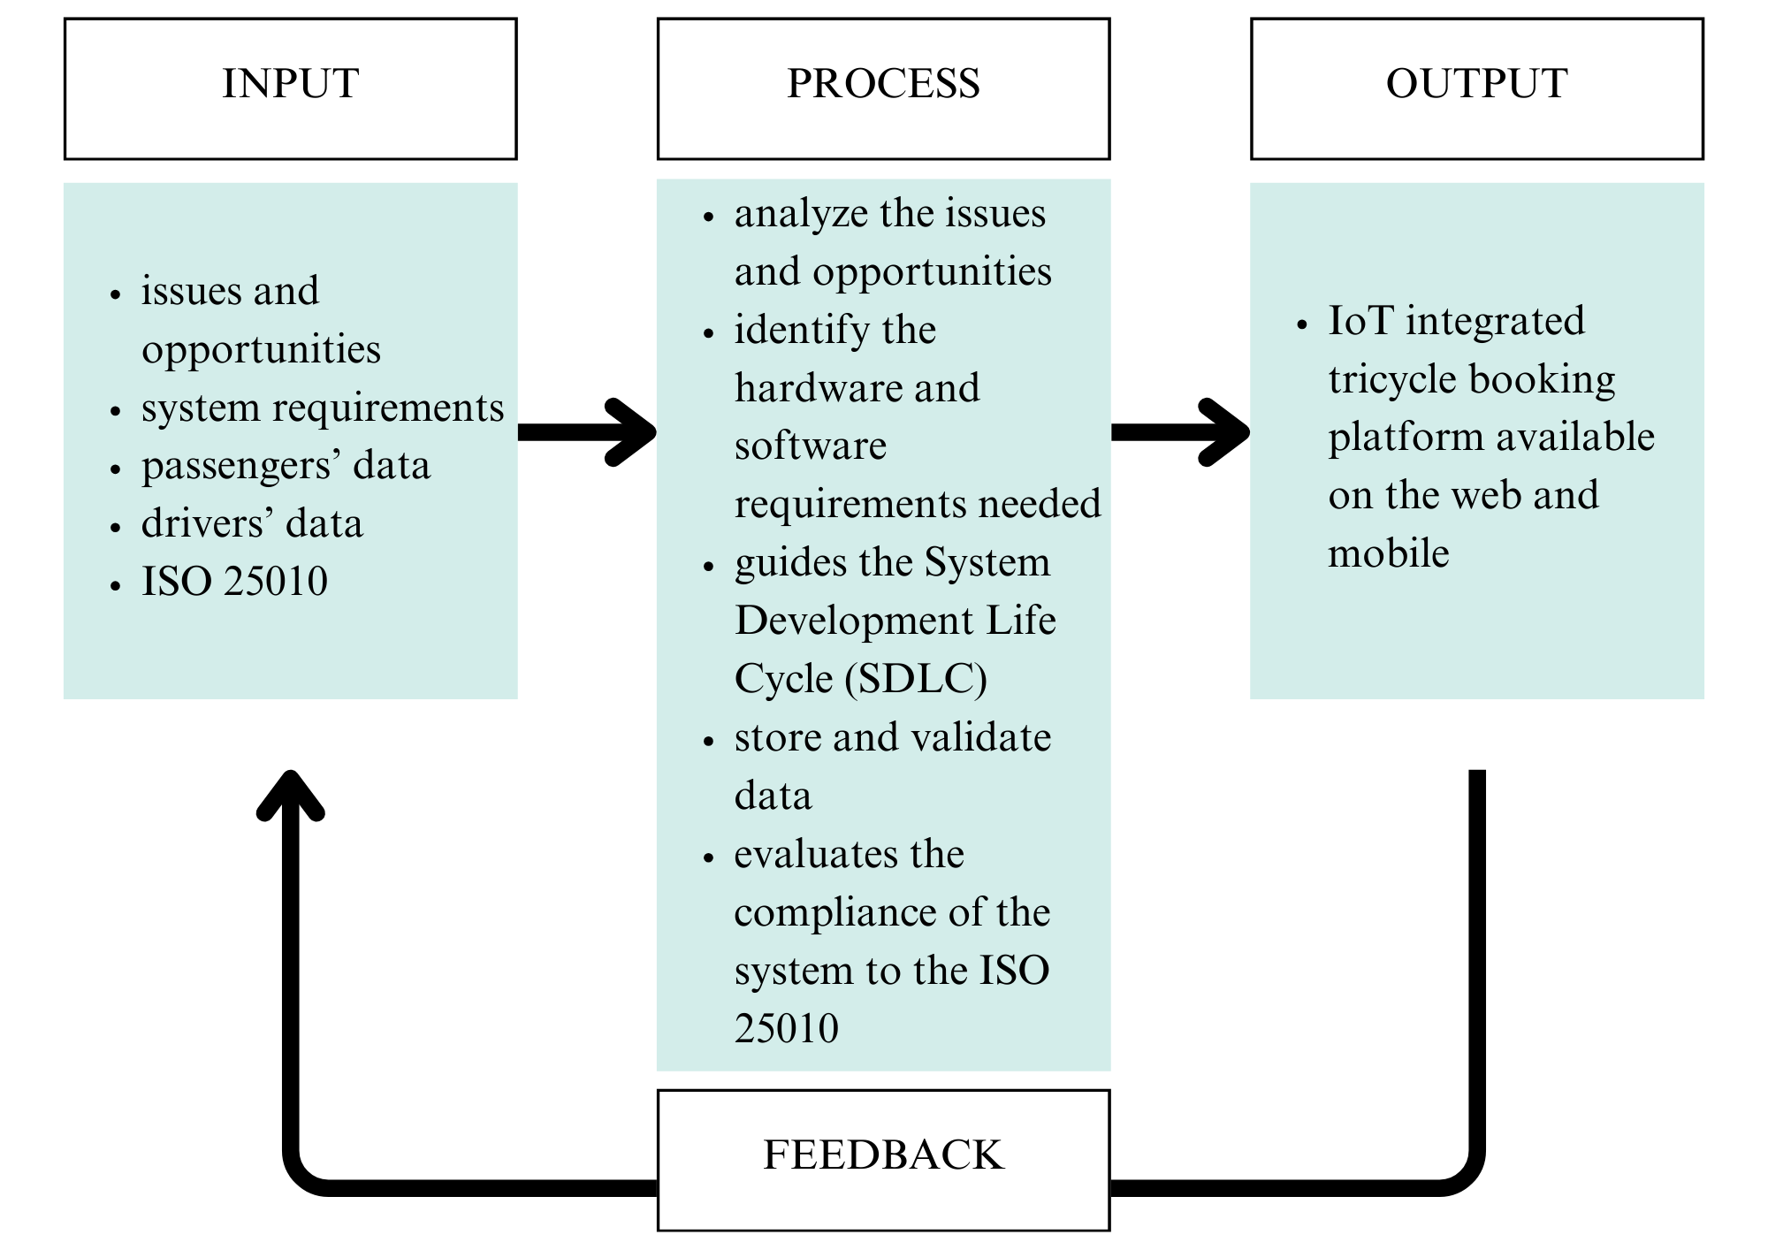

***Figure 1: Conceptual Framework for the Development of CSUTrike, an IoT Integrated Tricycle Booking Platform***

Figure 1 shows the input-process-output (IPO) model, a widely used framework that describes how the input of the system are processed to produce an output. The figure above illustrates the IPO model applied in the development of CSUTrike, an IoT integrated tricycle booking platform.

**OBJECTIVES**

This project aims to design and develop an IoT integrated tricycle booking platform available in the web and mobile, catering the community of Cagayan State University.

It also aims to:

1. Analyze the issues and opportunities presented by the challenge in the accessibility of transportation service inside the campus
2. Determine the requirements needed for the development of the system
3. Evaluate the compliance of the system to the ISO 25010

**SCOPE AND DELIMITATIONS**

The project aims to develop an IoT-integrated tricycle booking platform for web and mobile to improve the transportation services at Cagayan State University – Gonzaga by enhancing convenience and accessibility. The system allows students to book tricycle rides from specific locations within the campus. IoT technology for driver verification and real-time booking operation is applied to improve the overall convenience it will provide to the users. The system is designed for use by students and tricycle drivers.

The system covers the following:

* User Access and Role Management: The system will have different interfaces for students and tricycle drivers. These interfaces allow users to register and book rides while drivers can either confirm or decline their bookings.
* IoT Integration: The system will use RFID technology for driver authentication and Wi-Fi module for connectivity.
* Booking and Tracking: The system allows students to book tricycle rides from specific places in the campus and track available drivers real-time.
* Automated Report Generation: The system generates tricycle booking reports to track ride transactions and improve the efficiency of the system.

Limitations:

* Campus Exclusive Implementation: The system is specifically designed for use within Cagayan State University – Gonzaga.
* Student Commuters Exclusive: The system is specifically designed and developed for student commuters.
* Limited IoT Functionality: The integration of IoT is primarily for driver authentication, and system connectivity but does not include advanced GPS tracking.
* Platform Specific Accessibility: Students will only have access to the system via mobile and web applications, while tricycle drivers will use desktop application.
* Internet Dependence: The system requires an internet connection for real-time functionality.

**SIGNIFICANCE OF THE STUDY**

This project is significant as it introduces an IoT-integrated tricycle booking platform that is designed to make commuting within Cagayan State University – Gonzaga easier, faster, and more convenient. By combining real-time booking, automated tracking of available drivers, and IoT-based authentication, the system aims to simplify the transportation process for students and tricycle drivers. The following will benefit from this project:

* For Educational Institutions: This system helps improves campus transportation by providing a reliable and technology-driven transportation solution.
* For Students: The system will provide a user-friendly interface where they can book tricycles with just few taps on their phone instead of walking to the terminal, saving time and makes commuting around the campus much easier.
* For Tricycle Drivers: The system gives drivers a steady flow of passengers from inside the campus, helping them to earn more. More than just increasing their income, it also introduces them to a modern, digital way of managing bookings. They will learn to handle ride requests, use automated booking features, and interact with IoT-based technology, making their work more efficient and helps them adapt to the growing use of technology in transportation services.
* For Future Researchers: This study serves as foundation for future advancements in campus transportation, IoT integration, and smart mobility solutions.